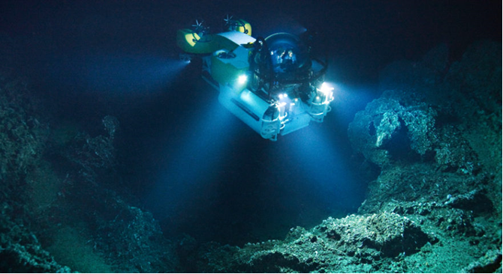

Technical Design Document

Team Dragon

Alex Feetham, Courtney Daniels, Simon Harris, Rebecca Bradburn, Krzysztof Chwiolka

BSc Games Technology | 05/12/2019……………..

Contents

Project Overview 2

Theme / Setting / Genre 2

Hardware and Software 2

Platform 2

Game Engine 2

Unity 2

Visual Studio 2

F-mod 3

Objects/Assets 3

Autodesk Maya 3

Online 3

Interaction and Gameplay 3

Spline 3

Lighting 4

Movement and Controls 4

Interactable NPC’s (Fish) 4

User Interface 4

Sonar 5

Audio 5

Audio List 5

# Project Overview

## Theme / Setting / Genre

Our project is an underwater expedition experience. The Mariana trench is the deepest know trench on the planet. Not many people have been down there so what a perfect way to use VR to allow someone to experience it for themselves.

# Hardware and Software

## Platform

The main platform in which we will develop the project for will be the Oculus Quest which will be in 6 degrees of freedom (DOF). We should also be able to create a 3DOF version that will be able to run on Android smartphones using Google Cardboards, or similar such third-party accessories, as the Oculus Quests use a version of Android. In addition, we should also be able to make the project compatible for use with Oculus Go’s.

## Game Engine

### Unity

For this project we intend to use the Unity Game engine. We have all used Unity extensively and 3 of us have used it in conjunction with the Oculus Rift which is why we have taken the lead on the programming side of the project. There is a free software development kit (SDK) available for the Oculus hardware which is compatible with Unity. This, combined with Unity’s virtual reality capabilities should make development a lot easier for us as the SDK comes with a lot of scripts that you can readily apply to objects so they may be interacted with. Unity will also allow us to build the project to run on various platforms including Android OS, Oculus Quest, Go, and Rift.

### Visual Studio

In addition to using the Unity game engine, we will also be using Visual Studio 2019. Visual Studio is a powerful integrated development environment (IDE) which can be used to program scripts in C#. Unity encourages developers to use Visual Studio and if installed will use it as the default application to open the C# scripts. There is also a plethora of documentation available both from Unity and various other sources to aid developers with their coding.

### F-mod

In addition to using Unity game engine, we will be using an add on called F-mod. The version we will be using is 1.10.12. this program helps with creating and placing audio sounds into a scene with scripts. There is a plethora of documentation available both from their website.

# Objects/Assets

### Autodesk Maya

Autodesk Maya is a 3D computer graphics application used for the creation of assets for interactive 3D application such as games or animated films. Maya also allows users to texture, shade and light your assets and most importantly, export them as OBJ or FBX. These are the most widely used file formats for 3D assets which is helpful for us as it allows for easy integration/importation to Unity. Some of the sorts of models we will need to create are:

* A main launch ship
* The submarine
* Sea life
* Sea plants such as corals and seaweeds

### Online

For this project, we are going to require a vast amount of different assets and as a small team there will not be time to create every asset from scratch. As such, we will use various online sources for some of our smaller assets which don’t require as much detail; such as sea life or general scenery objects. Some of these online sources will be sites like TurboSquid or the Unity Asset store. Any third-party assets used will be in accordance with their copyrights and referenced/credited.

# Interaction and Gameplay

## Spline

At the start of the experience, the submarine will be lowered down to the bottom of the trench along a set spline path. Along the way, a set of scripted events will occur in the form of different types of fish or objects floating past the window.

## Lighting

As you descend deeper, the light will fade out and you will need to turn on the submarine’s lights. When down the bottom of the trench and looking at some fish for example, you may want to turn off the lights to see something such as an angler fish.

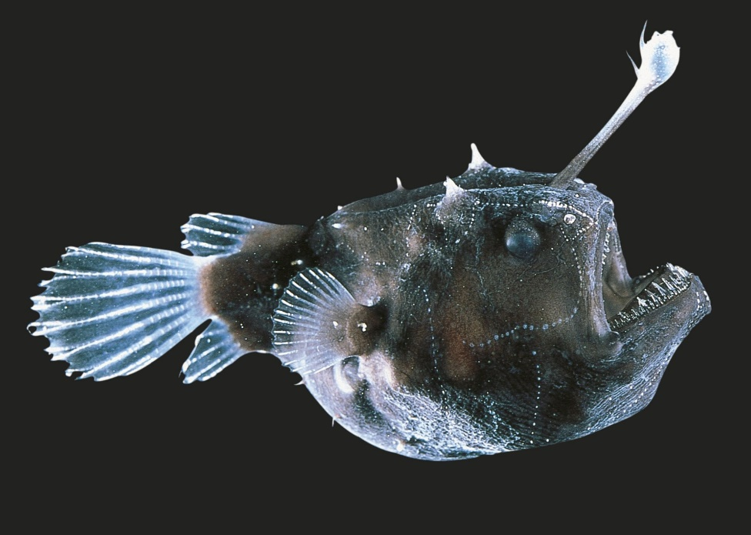

Image 1 [Angler Fish](https://www.dkfindout.com/us/animals-and-nature/fish/anglerfish/)

## Movement and Controls

The movement will be very simplistic to try to avoid any motion sickness. You will be able to use the joystick on the controller to move the submarine about the ocean floor. You can press a button to attach or detach from the winch line to go and explore or come back up to the ship to end the experience. The user can also look at an object to collect a sample like picking up rocks or other debris like plastic bags which will be included in the experience to aid in environmental conservation awareness.

## Interactable NPC’s (Fish)

The submarine lights will attract some fish and send others away scared so what you may or may not see will depend on this. Similarly, if you get too close to fish, they will swim away from you.

## User Interface

The UI will be a simple canvas which will display things such as depth, light levels, information on known fish species and educational information for Children.

## Sonar

The submarine will be equipped with a sonar to help map out the terrain and will also detect large objects such as big fish or schools of fish, wrecks and Rock formations.

# Audio

The audio will be created in house by our Audio Engineer. The list on the back of the TDD is our proposed Audio list for the game which will be a subject to change throughout the project. If we cannot recreate the sound, we will look for a royalty free version to use. We will be using F-mod for our audio Integration, the version of F-mod we will be using 1.10.1 F-mod is a Add on to Unity, which allows the user to add sounds to a scene and easily be able to edit and control the flow of sound with small about of scripting.

## Audio List

|  |  |  |  |  |
| --- | --- | --- | --- | --- |
| Name | Length | Type | Loop? | Notes |
| Motor of Sub | TBA | .Wav | Yes (when moving) | When sub is moving |
| Motor of Boat | TBA | .Wav | Yes | When near surface (fades) |
| Hum of electrics | TBA | .Wav | Yes | Sub |
| Winch Motor | TBA | .Wav | Yes | While descending/ascending |
| Wire tension | TBA | .Wav | No | While descending/ascending |
| Bubbles | TBA | .Wav | No | Atmosphere |
| Movement through water | TBA | .Wav | Yes, when moving | While descending/ascending |
| Sonar hum | TBA | .Wav | When sonar is active | While using sonar |
| Sonar Bleep out | TBA | .Wav | No | Button press for sonar |
| Sonar bleep back | TBA | .Wav | No | Finds something |
| Radio Comms | TBA | .Wav | No | Back to surface |
| Narrator | TBA | .Wav | No |  |
| Earthquake | TBA | .Wav | No | At sea floor Atmosphere |
| Gears | TBA | .Wav | Yes, when moving | Atmosphere |
| Fans | TBA | .Wav | Yes, Background | Atmosphere |
| Lever | TBA | .Wav | No | Usage of levers |
| Controls | TBA | .Wav | No | Usage of controls |
| Buttons press | TBA | .Wav | No | Press of button |
| Crowd on boat | TBA | .Wav | Yes, background | Crowd on boat awaiting to use the sub. Atmosphere |
| Chair sounds | TBA | .Wav | No | When chair is brought out/put away |
| Sub touchdown | TBA | .Wav | No | Sub hitting seafloor |
| Sub disconnect | TBA | .Wav | No | Sub disconnecting from winch |
| Sub connect | TBA | .Wav | No | Sub connect to Winch |
| Sample arm out | TBA | .Wav | No | Collecting sample |
| Sample arm in | TBA | .Wav | No | Returning sample |
| Door panel open | TBA | .Wav | No | Door for Arm |
| Door panel close | TBA | .Wav | No | Door for arm |
| Window panel open | TBA | .Wav | No | Additional windows opening |
| Window pan close | TBA | .Wav | No | Additional windows closing |
| Radio | TBA | .Wav | No | Switch radio on |
| Radio on/ off | TBA | .Wav | No | Switch radio off |
| Static | TBA | .Wav | No | Radio static (worse deeper you go) |
| Lights on | TBA | .Wav | No | External lights on |
| Lights off | TBA | .Wav | No | External lights off |
| Water lapping on boat | TBA | .Wav | Yes, Background | Water lapping on boat (surface) |
| Pressure groans | TBA | .Wav | Yes, background | Atmosphere |
| Whales | TBA | .Wav | No | Atmosphere |
| Sea life | TBA | .Wav | Yes | Atmosphere |
| Menu Music | TBA | .Mp3 | Yes |  |
| Grab | TBA | .Wav | No | Collecting samples |
| Credit Music | TBA | .MP3 | Yes |  |